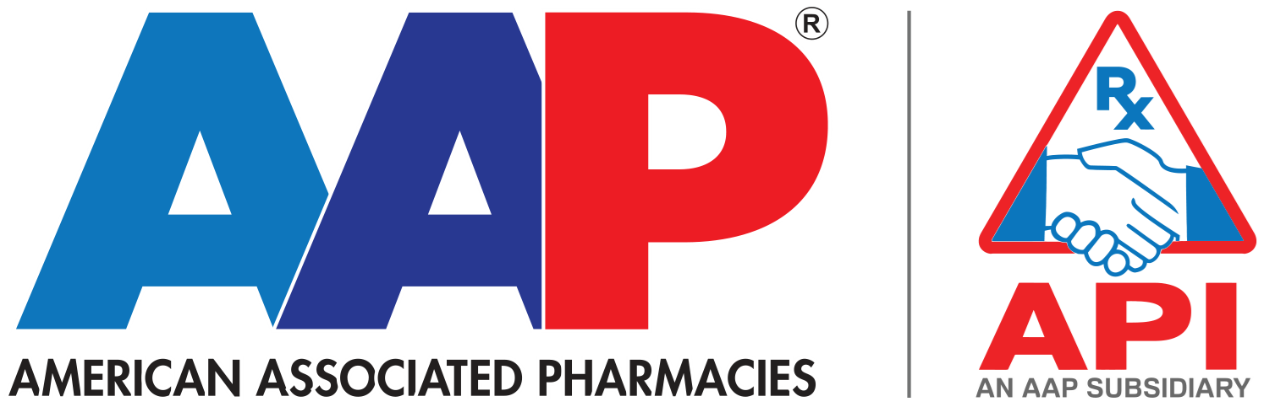

ADMIN ASSISTANT POLICY PLAYBOOK
Associated American Pharmacies (AAP) / Associated Pharmacies, Inc. (API)
Based on Employee Handbook effective May 1, 2024

Prepared on 01/03/2026

Table of Contents
Table of Contents 2
How this playbook works 3
Escalate to HR immediately for: 3
Quick Index (find the right section fast) 3
Employment basics (1xx) 3
Employment status and records (2xx) 4
Time off and benefits (3xx) 4
Timekeeping and pay (4xx) 4
Workplace practices (5xx) 5
Leaves of absence (6xx) 5
Attendance and conduct (7xx) 5
Other (8xx) 6
Employee FAQ: Approved Answer Scripts 6
Vacation accrual schedule (regular full-time) 7
Appendix: Full Handbook Section List 10
Document control 12

How this playbook works
This playbook is a companion to the AAP/API Employee Handbook. It is designed for day-to-day use at the front desk and in employee conversations: quick navigation, approved plain-language answers, and clear escalation points.
Golden rule
When answering policy questions: stay factual, stay consistent, and reference the handbook section. If the situation involves a dispute, medical issue, harassment concern, or any exception request, route it to the HR Manager.

Escalate to HR immediately for:
- Harassment, discrimination, retaliation concerns (Section 703).
- Medical restrictions, disability accommodation requests, or any leave certification questions (Sections 111 and 601).
- Work-related injuries and workers’ compensation questions (Section 313).
- Attendance point disputes or patterned/abuse situations (Section 704).
- Drug testing, suspected impairment, or safety incidents (Sections 702 and 710).
- Anything involving discipline, termination, or threats/violence (Sections 711 and 513).
Safe escalation line (use this script)
Here’s what the handbook says in general. Because your question is specific to your situation, I want to make sure it’s handled correctly and consistently. I’m going to connect you with HR.

Quick Index (find the right section fast)
Use this index for quick routing. The page numbers below refer to the handbook page shown in the handbook Table of Contents.

Employment basics (1xx)
Section | Policy | Handbook page
101 | Nature of Employment | 5
103 | Equal Employment Opportunity | 6
104 | Business Ethics and Conduct | 6
110 | Non-Disclosure | 7
111 | Disability Accommodation | 7
112 | Job Posting | 7

Employment status and records (2xx)
Section | Policy | Handbook page
201 | Employment Categories | 8
205 | Introductory Period | 9
202 | Access to Personnel Files | 9
204 | Personnel Data Changes | 9
207 | Performance Evaluation s | 10

Time off and benefits (3xx)
Section | Policy | Handbook page
301 | Vacation Benefits | 11
302 | Personal Leave | 12
303 | Long-term Sick Leave | 13
304 | Holidays | 14
306 | Bereavement Leave | 15
307 | Jury Duty | 16
313 | Workers’ Compensation Insurance | 18

Timekeeping and pay (4xx)
Section | Policy | Handbook page
401 | Timekeeping | 18
402 | Employment Termination | 19
403 | Pay Advances | 19
404 | Pay Deductions and Setoffs | 19

Workplace practices (5xx)
Section | Policy | Handbook page
501 | Safety | 19
504 | Smoking | 20
505 | Rest Periods | 20
506 | Overtime | 21
508 | Emergency Closings | 21
510 | Visitors in the Workplace | 22
511 | Computer and E-mail Usage | 22
512 | Workplace Monitoring | 23
513 | Workplace Violence Prevention | 24

Leaves of absence (6xx)
Section | Policy | Handbook page
601 | Family and Medical Leave | 24

Attendance and conduct (7xx)
Section | Policy | Handbook page
702 | Drug and Alcohol Use | 26
703 | Sexual and Other Unlawful Harassment | 26
704 | Attendance and Punctuality | 27
705 | Personal Appearance | 29
706 | Return of Property | 30
707 | Resignation | 30
711 | Disciplinary Actions | 31
712 | Problem Resolution | 31

Employee FAQ: Approved Answer Scripts
Use these scripts for quick, consistent answers. Keep your wording simple, cite the section, and avoid giving legal or medical opinions.
Q: How do rest breaks work?
Full-time nonexempt employees get two paid 15-minute rest periods each workday. Because it is paid time, employees should return to their workstations by the end of the rest period.
Handbook reference: Section 505 (Rest Periods)

Q: How does overtime work?
Overtime may be scheduled when business needs require it and must be approved by a supervisor before it is worked. Overtime pay is based on actual hours worked. Paid time off (such as personal leave, vacation, or a leave of absence) does not count as hours worked when calculating overtime.
Handbook reference: Section 506 (Overtime)

Q: What holidays do we observe and who is eligible for holiday pay?
AAP observes New Year’s Day, Memorial Day, Independence Day, Labor Day, Thanksgiving, and Christmas. Christmas Eve and the day after Thanksgiving may be a floating holiday depending on staffing needs. Holiday pay is provided to eligible regular full-time employees after completing 60 calendar days, and employees must work the last scheduled day before and the first scheduled day after the holiday to qualify.
Handbook reference: Section 304 (Holidays)

Q: If I work on a holiday, what happens?
Depending on department staffing needs, employees may be required to work on a designated or observed holiday. Employees who work a designated/observed holiday will receive a floating holiday to be used within 90 days, with supervisor approval.
Handbook reference: Section 304 (Holidays)

Q: How is vacation earned and used?
Regular full-time employees become eligible after 60 days of full-time service. Vacation accrues weekly based on length of service and cannot be taken in advance of accrual. Vacation is taken in minimum increments of two hours and requires advance supervisor approval.
Handbook reference: Section 301 (Vacation Benefits)

Vacation accrual schedule (regular full-time)
Length of employment | Paid days per year (hours) | Accrual rate (hours per week)
60 days to 1st anniversary | 3 (24) | 0.46
1st to 2nd anniversary | 5 (40) | 0.77
2nd to 3rd anniversary | 7 (56) | 1.07
3rd to 5th anniversary | 10 (80) | 1.54
5th to 9th anniversary | 15 (120) | 2.31
10th to 19th anniversary | 17 (136) | 2.62
20th anniversary and beyond | 19 (152) | 2.93

Q: Do I get paid out unused vacation if I leave?
Accrued but unused vacation may be paid out at separation according to the vacation policy.
Employees may request to ‘cash in’ vacation time as well
Handbook reference: Section 301 (Vacation Benefits)

Q: What is personal leave and how is it earned?
Personal leave is an all-purpose time-off policy (vacation, illness, or personal business). Eligible employees must complete a 60-day waiting period before using personal leave. Full-time personal leave entitlement increases with service: 3 days upon eligibility, 4 days after 1 year, and 5 days after 5 years. Part-time employees earn 1 hour for every 30 hours worked, up to the same annual maximums.
Handbook reference: Section 302 (Personal Leave)

Q: Does personal leave roll over or pay out?
Personal leave generally does not accumulate from year to year (unless required by state law). Upon termination, unused personal leave is not paid out.
Handbook reference: Section 302 (Personal Leave)

Q: What is long-term sick leave and when can it be used?
Long-term sick leave is a bank intended for extended illness events for regular full-time employees. It may be used only for three consecutive scheduled workdays or more when mandated by a physician for the employee due to extended illness, hospitalization, surgery, or recovery. It cannot be used for cosmetic services, follow-up visits, or absences shorter than three consecutive days.
Handbook reference: Section 303 (Long-term Sick Leave)

Q: How does the attendance points program work?
AAP uses a no-fault attendance points program for nonexempt employees. A grace period applies for tardies up to 5 minutes (0 points). A tardy or early leave of less than half shift is 0.5 points. Missing a half shift or more (including a full-shift absence) is 1 point. An absence with no report, or calling 15 minutes after the start of the workday, is 1.5 points. A full time employee is based on an 8hr shift and a part time employee is based on a 4 hour shift.
Handbook reference: Section 704 (Attendance and Punctuality)

Q: What happens as points add up?
Within a consecutive 12-month period: 5 points triggers a coaching session, 6 points a verbal warning, 7 points a written warning, and 8 points may result in termination.
Handbook reference: Section 704 (Attendance and Punctuality)

Q: What is the dress code?
Dress requirements may vary by department. Warehouse is casual, comfortable clothing with closed toe and closed heel shoes. Administrative departments require business casual Monday – Thursday and jeans and a t-shirt are permitted on Fridays.
Handbook reference: Section 705 (Personal Appearance)

Q: Can the company monitor computers, email, or video areas?
Company computers, files, and email are company property intended for business use and may be monitored. Workplace monitoring may also include telephone monitoring/recording, accessing computer files, and video surveillance in non-private areas for safety, security, and quality purposes.
Handbook reference: Sections 511–512 (Computer and E-mail Usage; Workplace Monitoring)

Q: If I resign, how much notice should I give?
Resignation is voluntary. While notice is not required, AAP requests at least 2 weeks’ notice from nonexempt employees and 4 weeks’ notice from exempt employees.
Handbook reference: Section 707 (Resignation)

Q: What property do I have to return when I leave?
Employees must return all company property, materials, or written information immediately upon request or separation. Where permitted by law, the company may withhold costs for unreturned items from a paycheck or final paycheck.
Handbook reference: Section 706 (Return of Property)

